Working With GAC

Step 1:(For Private Gac)

Create ConsoleAPP(.NET Framework) Project Sample

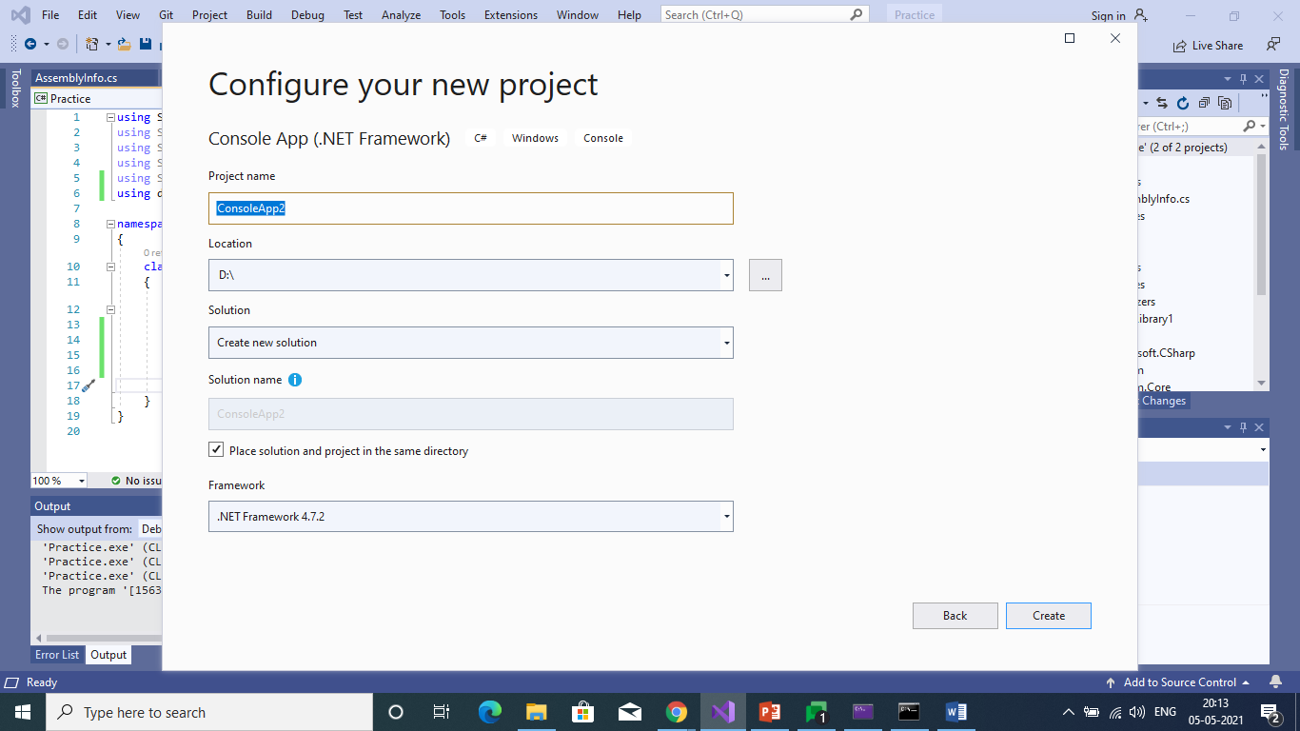

Step 2: Create ClassLibrary(.NET Framework)

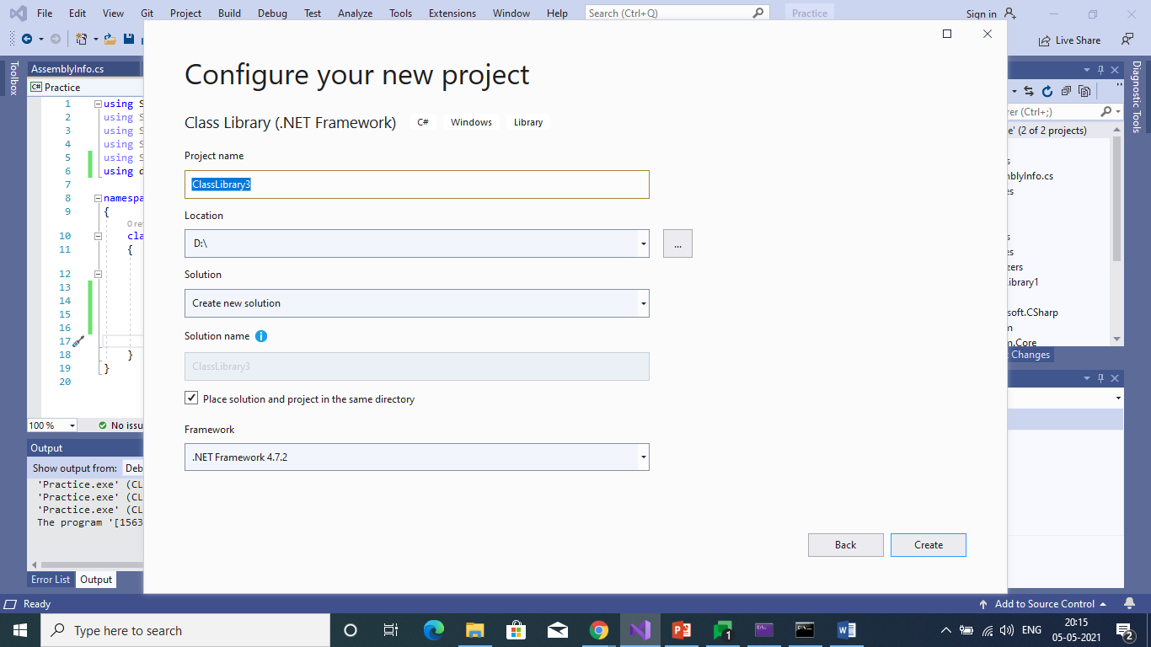

Step 3:

Add Reference to the Console App

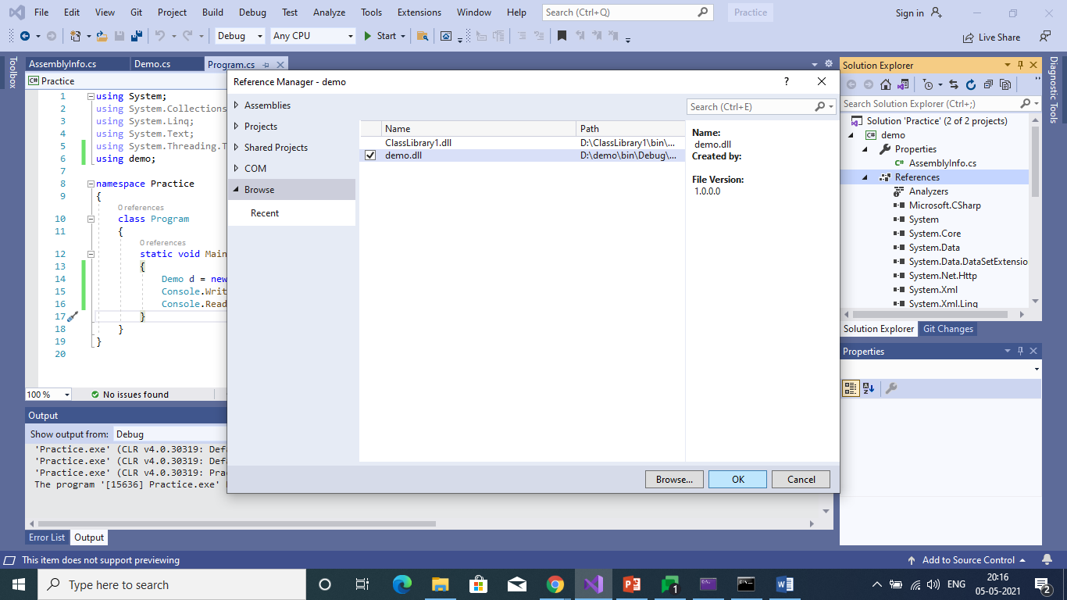

Step 4:(For Public Assemply)

Create strong nameKey

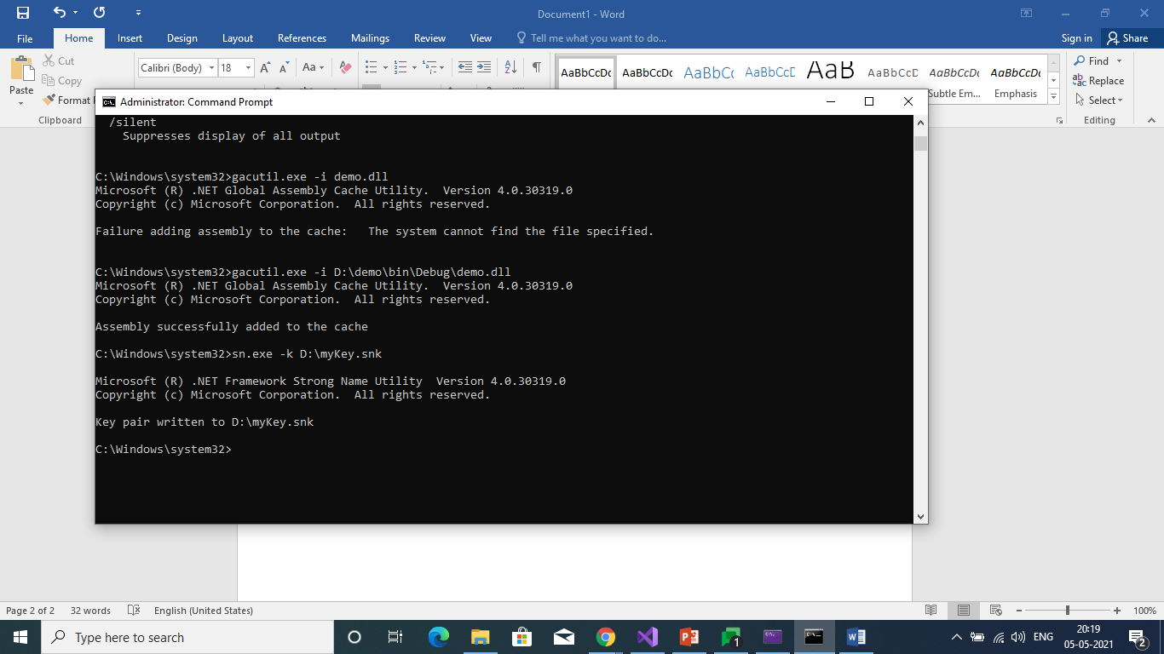

Step 5:

Assigning key to Assembly info.cs

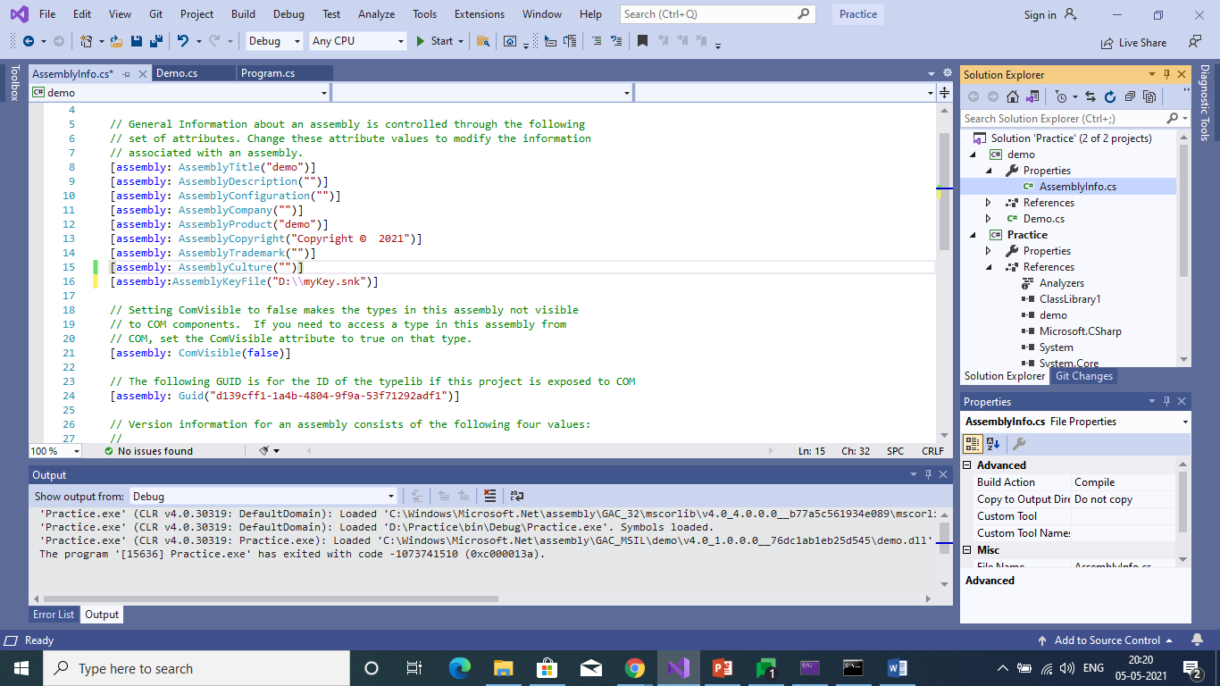

Step 6:

Insert dll into the GACMSIL

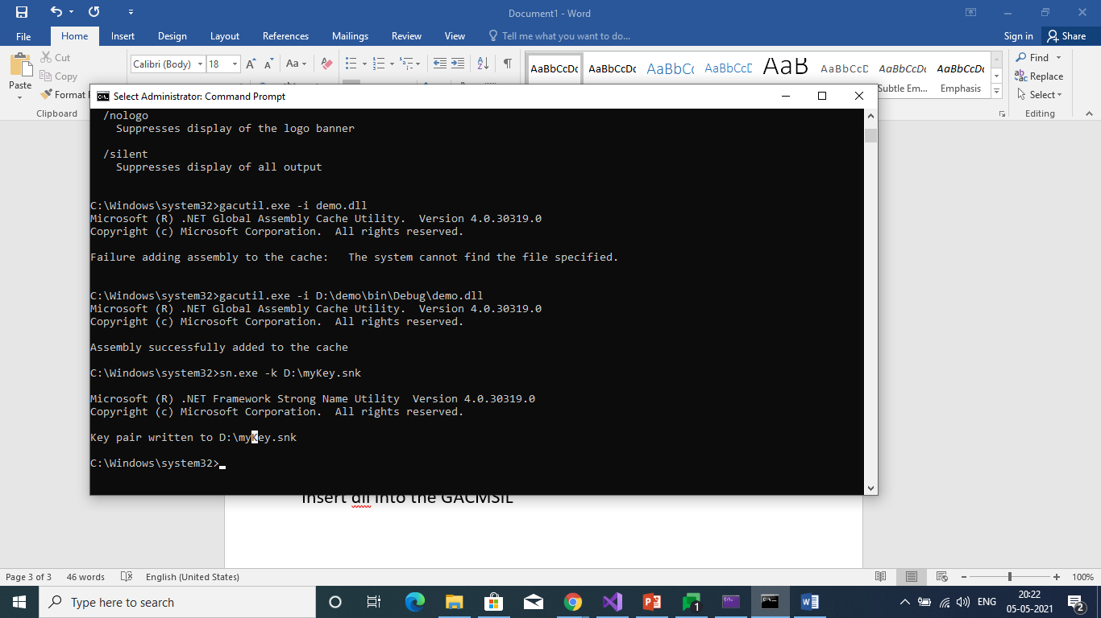

Step 7:

Our demo.dll in GAC

